Wednesday Track Sessions Overview.

Track Sessions Make You Faster!
If done correctly! As most experienced runners will tell you, the best way to learn how to run faster times is to get used to running fast. A one-paced strategy just won’t nibble away at that PB, whatever distance you like to run; so the best thing to do is practice. This means speed interval training and the track is the best place to execute these specific speed-enhancing sessions. For new runners, getting immediate and consistent feedback is critical to improving your ability to execute a specific skill. On the track, you can easily and accurately measure your pace every 100, 200, 300 or 400 meters. Once you start to develop a sense for the effort needed to run a certain pace, there is nothing to distract you.

Overall benefits of speed training
A lot of runners like to incorporate track sessions into their programme to focus on speed. Although it might not be everyone’s favourite session in terms of location and content, it is the perfect environment in which to focus on structured high intensity intervals to really hone your speed, fitness and running economy. The science behind the benefits of speed sessions include improved aerobic fitness and an enhanced ability to distribute oxygen-rich blood around the body to key muscle groups. Getting used to the bio-mechanical demands of running at speed will allow your body to adapt and improve your running economy and stride power, particularly over shorter distances. Plus the fact it will make those slower longer distance runs seem easy by comparison and over time, as you hone your sprinting skills, that natural speed will start to show up in your longer runs.
There are several ways you can work on speed at the track. You can either choose short, middle or long distance intervals, depending on your target race and current ability. The length and duration of those intervals depend entirely on your fitness, running level and requirements. And please don’t forget to warm up properly, especially before sprint sessions, or your hamstrings might not thank you for it.

Short speed intervals and why they work
Typically short intervals involve sprints of 100m, 200m or 400m with a suitable recovery in between. The idea is to boost your power and economy over a burst of short distance sprinting, which will ultimately help you maintain your marathon or longer distance race pace for longer. Over time you can extend the intervals and increase the number of repetitions, which will certainly improve your 5k speed. The key to success here is to make sure that you leave sufficient recovery time between intervals because each interval has to be run at the same flat out speed and intensity. If you don’t leave enough time to recover your speed will decrease and your ability to build power will be diminished. How you choose to recover between each sprint is up to you. You can either walk or jog as you prepare for your next sprint.

Middle distance speed intervals
Middle distance sessions are generally anything from 400m to around 1200m and these intervals should be run at something close to your 5k race pace. These sessions are all about improving your lactic acid recycling capability and your ability to resist the effects of fatigue. Muscles that are tired just don’t perform as efficiently, so the longer you can maintain a certain pace without getting tired, the greater the likelihood of achieving a PB. As a general rule after each of these intervals, give yourself a recovery period of around 2 to 3 minutes to allow the body to recover sufficiently and then repeat the interval with the same intensity as the first. But again, the duration of your intervals and recovery periods will be dictated by your level and ability.

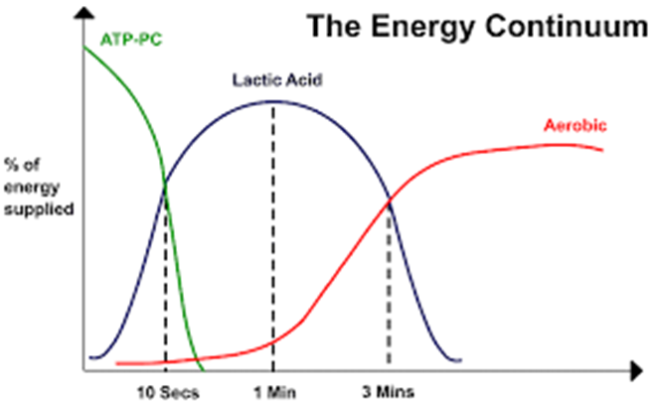

Long distance intervals
Long distance sessions tend to be anything from 1600m upwards and they should be run at something approaching your 10k race pace. This is primarily an exercise in lactate threshold running, which means running at such a challenging pace that lactic acid starts to accumulate in the blood. It’s not like an eye-bulging sprint, but a sustained pace that makes conversation difficult and feels hard. If you can maintain that pace over a sustained period, the body’s ability to recycle lactic acid increases. Over time this will enable you to be able to run further, faster and for longer. Just as with all of the other intervals though, it’s important to incorporate a suitable recovery period before going again.

Lee Corbett, UKA Coach in Running Fitness.

